How to add Records to the Query Security Tree

To be able to use Records in PeopleSoft Query the Record must be in a Query Security Tree.

Menu > PeopleTools > Security > Query Security > Query Access Manager
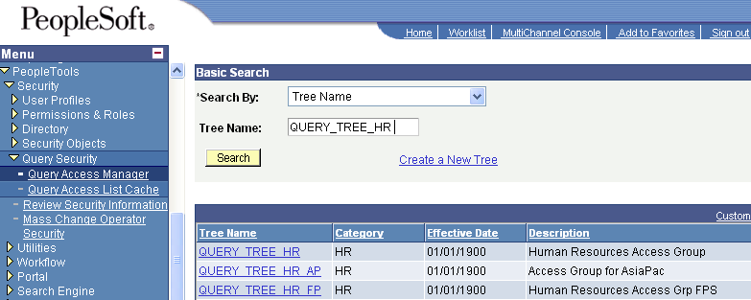

Insert the Record in the NAIT node by clicking the Insert Child Record icon
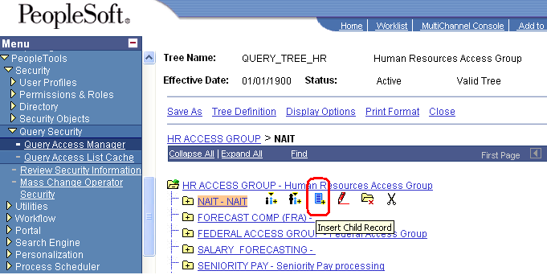

Click the Add button
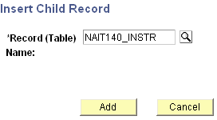

Once the Record is added click save and exit the page so others can access the tree.
